2021 SEC Boys Volleyball – All-Conference Awards
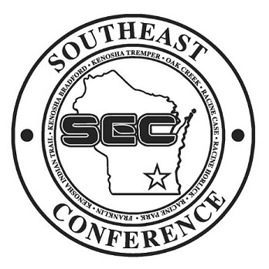
Conference Player of the Year: Josh Krueger – Kenosha Tremper
Offensive Player of the Year: Nathan Hill – Kenosha ITHSA
Defensive Player of the Year: Zander Feudner – Kenosha ITHSA
Coach of the Year: Chris Allen – Kenosha Tremper
Sportsmanship Award: Kenosha ITHSA
Conference Champion: Kenosha ITHSA

1st Team All-Conference |  |  |  |  | 2nd Team All-Conference
Ben Kearney – Franklin | 18 | Sr. | MH |  | Cameron Werner – Case | 13 | Jr. | RSH
Will Gardner – Franklin | 7 | Jr. | OH |  | Daniel Fish – Horlick | 12 | Jr. | OH
Nathan Hill – ITHSA | 5 | Sr. | RSH |  | Jack Esser – ITHSA | 9 | Sr. | OH
Zander Feudner – ITHSA | 1 | Sr. | S |  | Aiden Bratzke – ITHSA | 13 | Jr. | MB
Jackson Wilhelmson – ITHSA | 12 | Jr. | OH |  | Jake Glodowski – Oak Creek | 13 | Sr. | OH/DS
Brett Lucas – Oak Creek | 5 | Sr. | RSH/S |  | Jamier Pratt – Park | 3 | Sr. | S
Josh Krueger – Tremper | 12 | Sr. | OH |  | Wyatt Modory – Tremper | 13 | Sr. | S
Honorable Mention Awards
Franklin |  |  |  | Ben Gebhard and Ryan Kelly
Kenosha Bradford |  |  |  | Emilio Jaimes and Charles Pryse
Kenosha Indian Trail |  |  |  | Jackson Tirado
Kenosha Tremper |  |  |  | Andrew Michel and Joe Mendoza
Oak Creek |  |  |  | Izaac Neal and Cole Palkowski
Racine Case |  |  |  | Sam Riegelman
Racine Horlick |  |  |  | Zamarion Dyess and Jadin Dombrowski
Racine Park |  |  |  | Braden Roushia and Roger Lowe

